The Education System in Canada
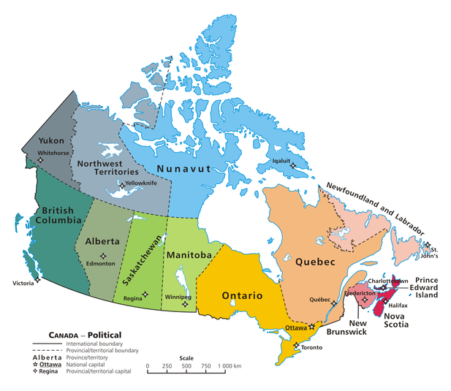

Administration
As in the United States, education in Canada is considered a local responsibility. Provinces have primary oversight over their education systems. 5.4 percent of Canada’s GDP is spent on education, with a heavy emphasis on tertiary education.

School Year
The school year in Canada lasts from early September, around Labour Day, to the end of June. Canadian students have 190 days of school each year, except for those in Quebec, who have 180.

Compulsory Education
Education is compulsory until age 16 in all provinces except Manitoba, Ontario, and New Brunswick, where schooling is compulsory until age 18 or until a student has received his or her high school diploma. Students typically begin school at the age of five (kindergarten) or six (grade one).

Language and Religion
Being able to learn in your own language and religion at a public school is considered a right in Canada. You will find some major cities have has many as four school boards – English secular, English Catholic, French secular, and French Catholic. French and English schools can be found in every province, with the most French schools located in Quebec. Additionally, immersion programs and bilingual schools are widespread throughout Canada. Bilingual schools are most often English/French, but in Western Canada especially other bilingual programs, like English/Chinese, have emerged.

Grade Levels
The grade levels for all provinces other than Quebec are similar.

Early Childhood
Pre-Kindergarten (ages 3-5)—unique to Ontario
Elementary
Grade 1 (6-7)
Grade 2 (7-8)
Grade 3 (8-9)
Grade 4 (9-10)
Grade 5 (10-11)
Grade 6 (11-12)
Junior High/Middle School
Grade 7 (12-13)
Grade 8 (13-14)
Grade 9 (14-15)
High School
Grade 10 (15-16)
Grade 11 (16-17)
Grade 12 (17-18)
Groupings of grade levels by school may vary by province. Some will have middle schools that comprise grades 6-8, whereas others follow the junior/senior high system.
Quebec:
Pre-school/préscolaire (under age 5)
Kindergarten/maternelle (5-6)
Grade school/école primaire
Grade 1 (6-7)
Grade 2 (7-8)
Grade 3 (8-9)
Grade 4 (9-10)
Grade 5 (10-11)
Grade 6 (11-12)
High school/école secondaire
Grade 7 /Secondary 1 (12-13)
Grade 8/Secondary 2 (13-14)
Grade 9/Secondary 3 (14-15)
Grade 10/Secondary 4 (15-16)
Grade 11/Secondary 5 (16-17)
CEGEP
CEGEP 1 (17-18)
CEGEP 2 (18-19)

CEGEP
CEGEP, or Collège d’enseignement général et professionnel (College of General and Vocational Education), is a pre-college university program unique to Quebec. Students from Quebec wishing to receive post-secondary education either in or outside of Quebec must first enroll in and complete a CEGEP program for at least one year. Quebecois students may not attend university with just a secondary education diploma; they must have completed a CEGEP program as well. Quebecoise students who have completed CEGEP can then enroll at a Quebec university and complete their Bachelor’s in three years.

Grading System
The grading system in Canada differs from that in the United States. Each province uses its own system, so it’s important to keep in mind which provinces your Canadian applicants come from. Most notably, grades between 90 and 100 are typically considered to be an A+, and grades in the 80’s are an A. Treat a student with an over 90 grade average like an honors student who is getting over a 4.0.

Alberta/British Columbia/Yukon Territory
Letter Grade | Numeric Grade | US Grade | Quality Points
A | 86-100 | A | 4
B | 73-85 | B | 3
C | 50-72 | C | 2 | Lowest passing grade
F | 0-49 | F | 0

Manitoba/Ontario
Letter Grade | Numeric Grade | US Grade | Quality Points
A | 80-100 | A | 4
B | 70-79 | B | 3
C | 56-69 | C | 2
D | 50-55 | D | 1 | Lowest passing grade
F | 0-49 | F | 0

New Brunswick
Letter Grade | Numeric Grade | US Grade | Quality Points
A | 86-100 | A | 4
B | 73-85 | B | 3
C | 60-72 | C | 2 | Lowest passing grade
F | 0-59 | F | 0

Newfoundland and Labrador/Northwest Territories/Saskatchewan
Letter Grade | Numeric Grade | US Grade | Quality Points
A | 80-100 | A | 4
B | 70-79 | B | 3
C | 60-69 | C | 2
D | 50-59 | D | 1 | Lowest passing grade
F | 0-49 | F | 0

Nova Scotia
Letter Grade | Numeric Grade | US Grade | Quality Points
A | 85-100 | A | 4
B | 70-84 | B | 3
C | 60-69 | C | 2
D | 50-59 | D | 1 | Lowest passing grade
F | 0-49 | F | 0

Nunavut
Letter Grade | Numeric Grade | US Grade | Quality Points
A | 80-100 | A | 4
B | 65-79 | B | 3
C | 50-64 | C | 2 | Lowest passing grade
F | 0-49 | F | 0

Prince Edward Island/Quebec
Letter Grade | Numeric Grade | US Grade | Quality Points
A | 80-100 | A | 4
B | 70-79 | B | 3
C | 50-69 | C | 2 | Lowest passing grade
F | 0-49 | F | 0

